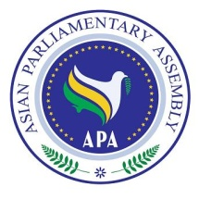
Draft Resolution on “Human Development in Asia”

SC- Social/ Draft Res/2019/13
14 February 2019

Recalling our commitment with the United Nations Sustainable Development Goals for the years 2015-2030, which includes poverty eradication and focuses on providing good health, welfare, appropriate education and work, and economy growth;
Reaffirming on APA Goals to harness cooperation to use enormous human and natural resources, and to ensure the interests of all member states;
Reminding parliament members of APA to take collective procedures for supporting governments and other active parties in the region, and to promote the exchange of opinions and expertise with parliaments from other regions, in the context of poverty eradication and promoting equality;
Recognizing that human development is an extensive and accumulative process that, does not only it care for the financial and economic aspects, but it also covers social, cultural, health, and political aspects, as its ultimate goal is human;
Affirming on the need to train Asian manpower and human resources to realize one of the most important feature of economic globalization by enhancing their competitive capabilities in the world market while utilizing the dynamics of globalization in which the balance of economic power keeps changing;
Therefore, we the APA Members,
1. Suggest creating a technical and professional training center under the umbrella of the APA to provide joint efforts to push sustainable development forward.
2. Encourage setting a unified criterion for national capacity building.
3. Promote coordination based on professional standards that are set by professionals
in the work market.
4. Urge rich countries in Asia to support the proposed training center project and
encourage their parliaments to take steps towards the realization of this goal in
compliance with the United Nations Sustainable Development Goals.

